


Business Requirement Document
​ project name​
Prepared for
Client name
05.10.2023
Version 1


Prepared By:
Exponentia.ai Pvt Ltd

AUTHORS
Name | Role | Department
Ravi Rakesh | Sr. Business Analyst | IT

DOCUMENT HISTORY
Date | Version | Document Revision Description | Document Author
23-10-OCt | 1.0 | BRD Creation | Ravi Rakesh

APPROVALS
Approval Date | Approved Version | Approver Role | Approver
 |  |  | Chirag Sahlot

Contents
1. Introduction 4
2. Solution Overview 6
3. Project Scope 8
4. Terms/Acronyms, Definitions & Related Documents 9
5. Required Solution Flow 10
6. Module wise requirement mapping 11
6.1 Data Ingestion Pipeline 11
6.2 Configure Threshold Process 13
6.3 Task Closure Verification Module 18
6.4 Task Eligibility & Trigger Module 21
6.5 Task Optimization & Assignment Module 27
6.6 Admin Console UI 28
6.7 Performance Tracking Qlik Dashboards 28
6.8 Serving API connectivity with iEarn App Frontend 28
7. Expected Production Stage End Stage 28
8. Development Priorities 29
9. System Requirements 29
10. Integration Requirements 29
11. Non-Functional Requirements 30
12. Exception Handling Error Reporting 32
13. Stakeholder Mapping 32
14. Assumptions & Pre-requisites 33
15. Exclusions 33
16. APPENDIX 34

Introduction
Overview
Globalization has significantly impacted the way an organization operates. Over the last few years, Companies have recently been more conscious of the necessity of strategically leveraging data assets to capitalize on market prospects. Many businesses increasingly realized the value of having a data strategy to beat the competition, either through competitive analysis or by comprehending operational patterns. A lean data pipeline is paramount in achieving this objective as it ensures low cost of services and efficient data handling.
About client
This proposal is for HDFC Life, a leading public listed insurance service provider looking to develop a system with an ML–Based approach to forecast monthly collections for the upcoming year.
Background
iEarn - an ML based application aims at improving the FLS efficiency with the help of gamified incentives that encourage the desired behaviour across channels. The completion of a task will help FLS/FC receive task pay-out and boost overall productivity. This helps in maximizing the total incentive earnings for the FLS based on the incentive structure. Nudges are sent to FLS/FC for specific tasks depending on their historical performance. For FLS/FC, the system currently uses simulation and optimization to determine the ideal set of tasks for a given reward.
Current Challenges
- The current iEarn setup is challenging for business users as it behaves like a black box and offers little control to business users as most of the tasks are currently being handled by established ML models.
- The system also offers a challenge if the business wants to ensure price uniformity across a segment/sub-segment. This is because the system currently is hyper-personalized when it comes to task rewards, i.e., in a particular segment individuals may be offered the same task at different price points. The business recognizes this as a barrier in driving a desired behaviour for FLS/FC.
- Business also wants to do away with data pipeline spread across multiple aws accounts and wants to setup pipeline in one account. Currently the data pipeline setup faces challenges around having more than necessary data or data excess at several points be it Raw, L1 or L2.
- Apart from this the system also has challenges like inactive pipelines, high incovation of lambdas, real time task closures (not needed for business operations) and high cost of services.
.

Solution Overview
Solution Proposed
To address the above challenge and to have better control over the distribution of incentives for certain tasks at the segment level, the firm intends to do away with the simulation and optimization model.
The iEarn system will need to be updated by decommissioning the ML models before installing a rule engine that will make it easier for business users to comprehend how the system functions. The ML models will be replaced by a rule engine, which will simplify the system and provide business users with more control. A GUI will be created that enables business users to manually establish pricing at the Micro Segment level. This simplifies the portal so that corporate users have more control. For data pipeline all the transformation R / L1 / Final tasks will be designed in the same account.

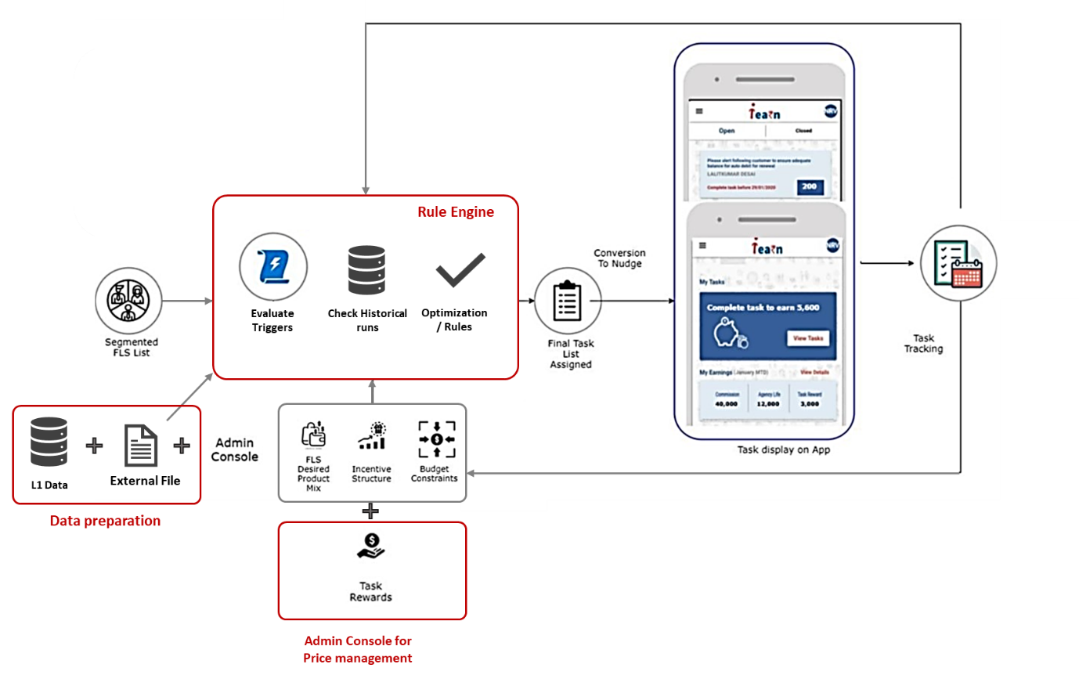
Figure: Propose iEarn system - Conceptual
Note: Above diagram does not represent sequential activities of pipeline. Representation is regarding the major components only.

iEarn Application architecture will be based on key data pipeline design principles to meet the growing functionality needs at optimal cost.
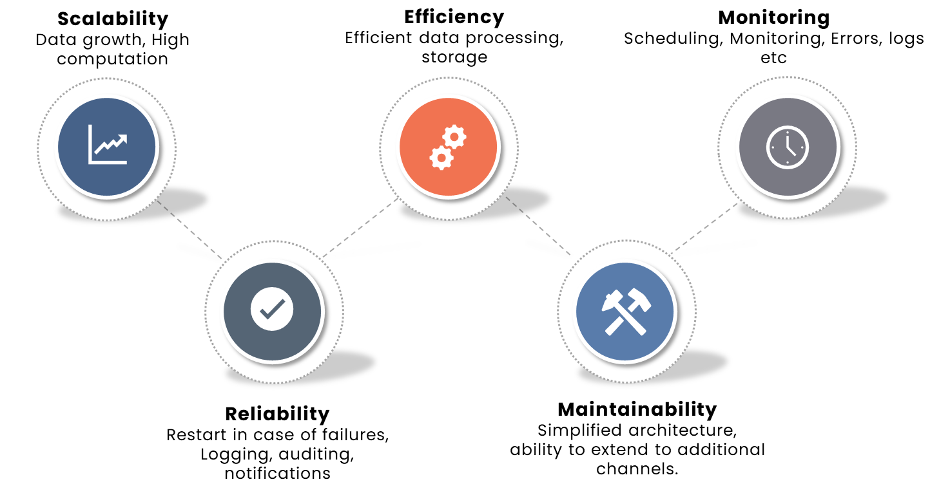
Figure: Key design principles for data pipeline development

Solution Guidelines provided by HDFC Life team:
  - Solution will be developed and deployed on HDFC Life’s AWS, ADCAT Account
  - Real time processes are not required. The closure of tasks will also happen once a day. FLS/FC will receive the status of their completed task on the next day of completion date
  - Data Redundancy on storage should be minimized
  - Only tables and attributes which are required should be stored in the database.
  - Simplicity in understanding the flow of the data
  - Minimal computation around the transformation and logic development should be the development focus
  - Development focus should be on making the system configurable on below items
• Trigger thresholds at channel-segment level
• Task and trigger mapping at channel segment level
• Optimization rules at channel segment level
• Closure rules at channel segment level
  - Two ways of changing/updating configurations are targeted within scope
- Using Config files in S3
- From Frontend UI
  - The system should be tested and validated for 3 channels and associated tasks finalized (37 Tasks, 44 Triggers details provided in Appendix)

Project Scope
Sr. No. | Module | Sub Module
1 | ETL Pipeline from Data Lake/EDW to L1 | Data Mapping from DataLake & EDW
 |  | Incremental/Historical Data Upload strategy
 |  | ETL pipelines from Datalake/EDW to L1 (consumption Layer)
 |  | Data Quality and validation checks
 |  | Pipeline Orchestration
 |  | Error logging & notifications
 |  | Data Modelling at RDS
2 | Monthly Threshold Pipeline | Config Templatization & validation
 |  | Threshold Pipeline Logic Development
 |  | Pipeline Orchestration
 |  | Functional & Integration Testing
 |  | Error logging & notifications
3 | Task Closure Module | Config Templatization & validation
 |  | Closure Pipeline Logic Development
 |  | Pipeline Orchestration
 |  | Functional & Integration Testing
 |  | Error logging & notifications
4 | Task Eligibility & Trigger Module | Config Templatization & validation
 |  | Closure Pipeline Logic Development
 |  | Pipeline Orchestration
 |  | Functional & Integration Testing
 |  | Error logging & notifications
5 | Task Optimization & Assignment Module | Optimization Rules, Config Templatization & validation
 |  | Optimization Pipeline Logic Development
 |  | Pipeline Orchestration
 |  | Functional & Integration Testing
 |  | Error logging & notifications
6 | Admin Console UI | Admin User Stories
 |  | UI/UX design & Wireframing
 |  | Front End Development
 |  | Backend Integration
 |  | Function & Integration Testing
7 | Performance Tracking  Qlik Dashboards | BI Use cases and requirements
 |  | Dashboard Wireframing
 |  | Dashboard Development
 |  | Function & Integration Testing
8 | Serving API connectivity with iEarn App Frontend | API usage discovery, effort estimation and solutioning
 |  | API migration from Sorocco to Adcat
 |  | API testing through client application like Postman
9 | DevOps | CI/CD as and where required
 |  | Cost and Usage tracking by environments, users, and modules

Terms/Acronyms, Definitions & Related Documents
Name (with link to the document) | Description
Config File | A worksheet for referring to agreed templates on various config
Data Lineage & Requirement Mapping | A worksheet having all information on data requirements and mapping to source tables

Term | Description
FLS | Field level Supervisors are the insurance agents employed by HDFC
FC | Financial Consultants are the licensed insurance agents not employed by HDFC but work on commision basis
Channel | The Channel through which lead was sourced happen. See Channel-Subchannel Master for all channel list
SubChannel | The Sub Channel through which lead was sourced. See Channel-Subchannel Master for all channel list
Demo Segment | Every FLS/FC are further segmented in demographic segments as per the channel. See Channel- Demo- Value-Seg Master
Value Segment | Every FLS/FC are further segmented in value segments as per the channel. See Channel- Demo- Value-Seg Master
MicroSegment | Combination of Channel-Subchannel-Demo Segment-Value Segment forms a unique microsegment
Task Assignment | Tasks are assigned to FLS at daily level. If the FLS/FC works on the task then he is rewarded
Task Closure | When a FLS completes his/her assigned task, it is called task closure
Task | Tasks are actions which FLS needs to take like Meeting Tasks, Selling Tasks, Post Login Tasks, Aversion Tasks etc. See Task Master.
Trigger | A FLS becomes eligible for a Task, if the set of Trigger condition are true
Thresholds | Thresholds are metrics to benchmarks FLS and Segment performance so that it can be taken as a standard for comparison
Lead | Any new contact the FLS/FC register in CRM and consider them as a prospect
Optimization_Output | This is the iEarn v1 version of the output generated every day which had list of recommended task for FLS/FC and other details. See Optimization Output in Appendix
Policy | All approved applications convert to policies
FR | FRs are further requirements raised to scruitinize whether a policy should be issued or not. Various types of FR can be raised like KYC docs, Income proofs, medical certificates etc.

Required Solution Flow
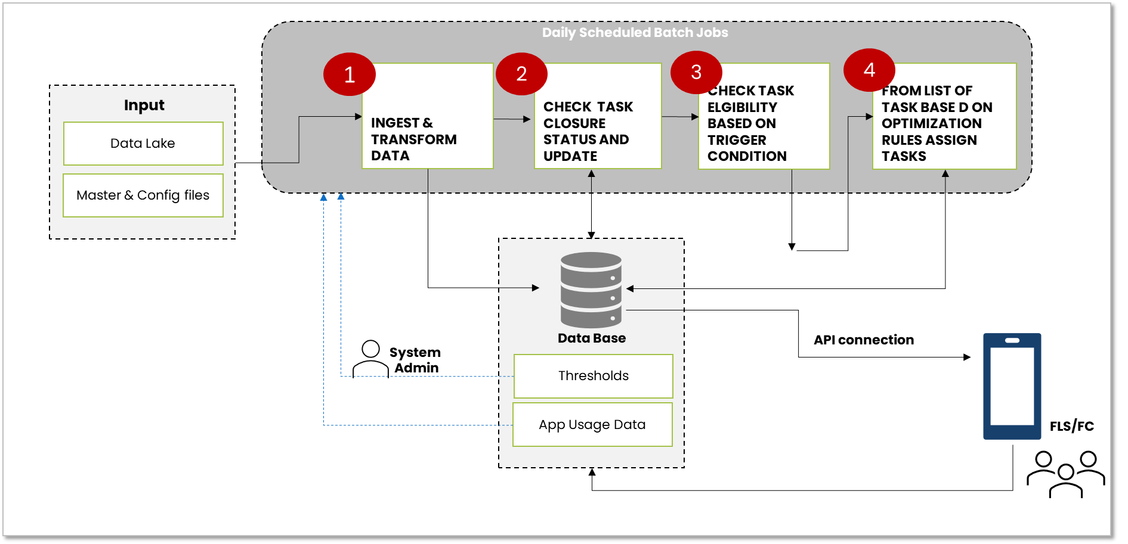

Fig. Solution Flow
List of steps expected in the above pipeline:
- Daily one schedule pipeline will run, preferably early morning. The first step will be to extract the latest data from source S3, select the required feature, apply transformations as required and create L1 Layer (consumption layer) in Data base.
- The second step will run task closure scripts and assign the latest status on each task assigned to an FLS/FC
- Next Task & trigger Module will run which will check for eligibility of the task to an FLS as of latest current status
- Finally, Task Assignment Module based on the optimization inputs and expected outcomes will assign tasks to an FLS/FC.
- The daily optimized task assignment list for the FLS /FC will be stored back in the database and connectivity for output to be sent to iEarn app using API connection has to be established.

Module wise requirement mapping
The expected solution has been discussed and grouped in modules as listed below:

Data Ingestion Pipeline

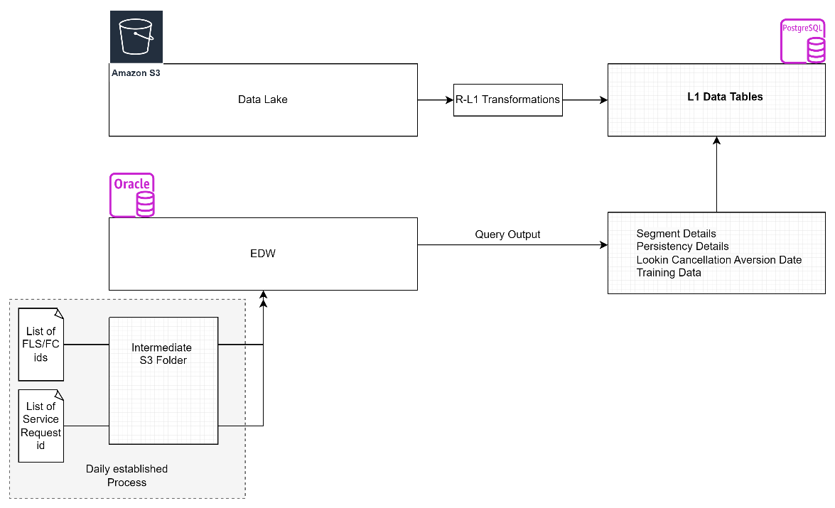
Fig. Recommended ETL process diagram

Running Frequency: Daily
Process: Automated Scheduled Jobs

- An automated daily ETL pipeline which will read data from data lake on Adcat Account is needed
- The respective S3 locations for the required Athena data tables (Data Lake) need to be mapped and reading accesses need to be acquired
- Data lake source files in the respective S3 locations will be available in parquet format
- For minimal reading and processing, only those columns which are required by the model needs to be ingested in consumption layer(L1)
- Transformations from Raw (data lake) to Consumption layer needs to be done as per the requirement using transformation dictionary provided in Discovery phase.
- New transformation logic or changes in existing logic can also be done as per the data model requirement at Consumption Layer(L1)
- Considerations need to be taken in care to maintain minimal data redundancy and processing
- Not more than six months of historical data will be used in any functional modules, hence optimal incremental and purging strategy to maintain minimal load at the RDS (Postgres) should be designed
- Triggers are assumed to be calculated based on last 6 months data only and not beyond that period
- Some data might also be read from EDW (Oracle Db) or any other source. Respective connection details and accesses need to be acquired and implemented
- For FLS Persistency data, a process needs to be established to provide list of FLS_ID/FC_ID to persistency team at a daily level and then output with segment mapping will be received from them on S3 itself
- For Look in cancellation aversion date, a process needs to be established to provide list of Service Request ID to persistency team at a daily level and then output with aversion date mapping will be received from them on S3 itself
- Proper documentation for Raw to Consumption layer transformation, data model and entity relationship models needs to be created
- Data Lake will be taken as source of truth. All data validation and checks need to be matched with data available at Data Lake
- In case of pipeline failure, alerts should be sent to respective stakeholders. Stakeholder mapping for the alerts needs to be maintained
- Cost tags for the infrastructure usage should be appropriately tagged and monitoring process established
- Time of scheduling the job will be proposed by the development team and must be mutually agreed by leadership team
References: Data Lineage & Requirement Mapping file (Appendix)
Module | Data Ingestion Pipeline
Primary Actor(s) | System
Stakeholders | System Team
Trigger | Daily Scheduled as per the requirement
Pre-conditions | - Availability of the Data in Data Lake  - Availability of supporting master mapping files
Validations | - Data Quality checks need to be done
Main Success Scenario | - Threshold at FLS and segment level are derived, validated, and stored for usage in other modules
Priority | High
Error Messages | - An email is sent to admin team indicating the pipeline failure

Configure Threshold Process
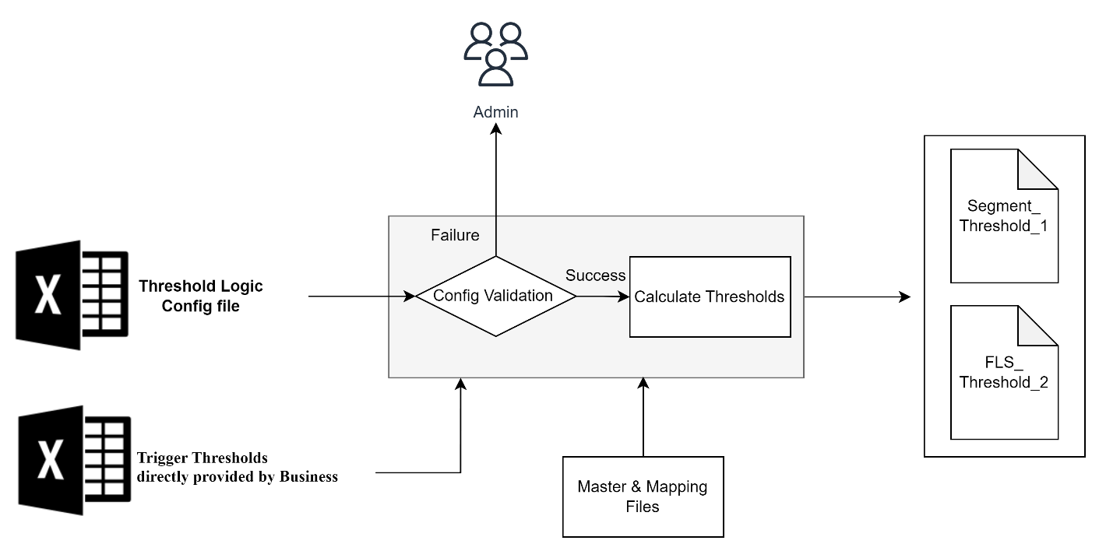
Fig. Monthly Threshold Process
Running Frequency: Monthly
Process: Automated Scheduled Jobs

- Thresholds are specific to a Trigger and can vary with Channel-Sub Channel Mapping or Micro-Segment Mapping. It is the benchmarked performance indicator at FLS or Microsegment level
- An automated monthly threshold calculation pipeline which will primarily set two types of thresholds
  - FLS level average performances around various metrics
  - Microsegment Level benchmark around various metrics
- Objective is to calculate two types of Thresholds
  - Segment_Threshold_1: This is a threshold for a trigger aggregated at Microsegment Level
  - FLS_Threshold_2: This is a threshold aggregated at FLS level
- Analysis period is the historical number of days to be considered for calculating Thresholds for the respective Trigger. This needs to be provided by business in Threshold Logic Config file. This can be updated as and when required but ideally should not exceed 180 days, as ETL pipeline is processing only 6 months data.
- Some of the Trigger Thresholds might not be calculated and will be directly provided by the business
- For some FLS (recently joined or attributes not available) or segments, where Thresholds cannot be calculated, assign them default segment 00 and Channel Level default Thresholds has to be used to assign thresholds for them

EXPECTED JOB PROCESS
Step 1: Establish and validate Threshold Logic Config file
Step 2: Receive and validate Trigger Thresholds directly provided by Business
Step 3: Process code for developing two output threshold files
- Segment_threshold_1_Output_file
- FLS_threshold_2_Output_file
Step 1
- Threshold Logic Config file will have list of all the Triggers applicable with its description
- Each Trigger can have dependencies on both Segment_Threshold_1 and FLS_Threshold_2 or any of them or none
- Threshold description is textual description of the logic for threshold calculation
- Threshold query logic is the query statement that should be executed to find the calculated column for respective thresholds
- Operation is the type of aggregation operation that needs to be done on the calculated column
- If Operation == Average, thresholds has to be calculated by aggregating calculated column as averages at FLS and Segment Level
If Operation value==Manual, use the trigger thresholds directly provided by the business team
- Operation Value can be blank only in case where there is no requirement for threshold
Trigger_id | Trigg_Desc | Thres_Description | Thres_Query_Logic | Operation | Analysis_Period | Num_thresholds_required | Segment_Threshold_1_Requirement_Flag | FLS_Threshold_2_Requirement_Flag
1 | If Last N month's avg TAT between lead generation and set up of meeting has been greater than segment benchmark X | X- (Average # days for segment between lead generation and setup of first meeting)+ 1 | Select (lead_generation_date - first_meeting_scheduled_date) +1 from lead | Average | 180 | 2 | 1 | 1
2 | If X days have elapsed after lead generation, and yet first meeting has not been setup (applicable for all leads with status "New" without a future meeting date) |  | Select (lead_generation_date - first_meeting_scheduled_date) +1 from lead | Average | 180 | 1 | 1
3 | If X days have elapsed after lead generation, and yet first meeting has not been conducted (applicable for all leads with status "New" with a future meeting date) | X- (Average # days for segment between lead generation and conduct of first meeting)+ 1 | Select (lead_generation_date - latest_meeting_scheduled_date)+1 from lead | Average | 180 | 1 | 1
4 | If Last N month's avg TAT between lead generation and first meeting has been greater than segment benchmark X | X- (Average # days for segment between lead generation and conduct of first meeting)+ 1 | Select (lead_generation_date - latest_meeting_scheduled_date) +1 from lead | Average | 180 | 2 | 1 | 1
35 | If the FLS is more than X months old in system | X= Segment benchmark for years of association with the system |  | Manual |  | 1
36 | If there has been no application logged in by FLS in past x days | XX->Average time taken to sell 1 policy in the segment | Select (lead.lead_generation_date - policy.policy_issuance_date) from lead,policy | Average | 180 | 1 | 1
8 | If x days have elapsed since application login and application is still pending for verification | X- Segment average TAT for login till conversion | Select (application_login_date - policy_issuance_date) from lead, policy | Average | 180 | 1 | 1
37 | If there is an open medical FR |  |  |  |  | 0
38 | If x days have elapsed since medical FR was raised | X- Segment average TAT for medical FR closure (From FR raise till document submission by FLS) |  | Average | 180 | 1 | 1
39 | If Last N Day's avg TAT for medical FR Closing is greater than segment benchmark X | X- Segment average TAT for medical FR closure (From FR raise till document submission by FLS) |  |  | 180 | 2 | 1 | 1
40 | If there is an open non medical FR |  |  |  |  | 0
41 | If x days have elapsed since non medical FR was raised | X- Segment average TAT for non medical FR closure (From FR raise till document submission by FLS) |  |  | 180 | 1 | 1
42 | If Last N month's avg TAT for nonmedical FR Closing is greater than segment benchmark X | X- Segment average TAT for non medical FR closure (From FR raise till document submission by FLS) |  |  | 180 | 2 | 1 | 1
43 | If there is an open single non medical FR |  |  |  |  | 0
44 | If x days have elapsed since single non medical FR was raised | X- Segment average TAT for single non medical FR closure (From FR raise till document submission by FLS) |  |  | 180 | 1 | 1
45 | If Last N month's avg TAT for single nonmedical FR Closing is greater than segment benchmark X | X- Segment average TAT for single non medical FR closure (From FR raise till document submission by FLS) |  |  | 180 | 2 | 1 | 1
9 | If combo conversion rate for past N months has been less than x% (x being benchmark of the segment) in last N Months of policies sold | X% - Segment average combo conversion rate for past 6 months |  |  | 180 | 2 | 1 | 1
46 | If there has been no combo sold in past X days | X - Set by business team |  | Manual |  | 1 | 1
47 | If there has been no rider sold in past X days | X - Set by business team |  | Manual |  | 1 | 1
10 | If rider conversion rate for past N months has been less than x% (x being benchmark of the segment) in last N Months of policies sold | X% - Segment average rider conversion rate for past N months |  |  | 180 | 2 | 1 | 1
49 | If renewal for customer XX tagged to the FLS is not received within N days after due date | X - Set by business team |  | Manual | 180 | 1 | 1
12 | If payment is to be made through ECS mode |  |  |  |  | 0
13 | If persistency for the FLS is lower than x% | X - Set by business team |  | Manual |  | 1 | 1
11 | If renewal for customer XX tagged to the FLS is due in x days | X - Set by business team |  | Manual |  | 1 | 1
14 | If SI ECS not tagged |  |  |  |  | 0
48 | If there are no focus Product policy sold till date in the month for FLS |  |  |  |  | 0
16 | If FYFP of focus products policies sold is less than x% of total FYFPof segment for last N days | X%=(Desired C2P/ Health product mix for channel (basis FYFP))*1.5 |  | Sum | 180 | 1 | 1 | FLS Last N Days FYFP
58 | If there has been >1 application logged in by FLS in past XX days | X - Set by business team |  | Manual |  | 1 | 1
17 | If the customer has a birthday today |  |  |  |  | 0
19 | If FLS has not sold any of the focused products in the last N months | X - Set by business team |  | Manual | 180 | 1 | 1
54 | If FLS has been in the system for N days & not completed corresponding mlearn training in last X days | X - Set by business team |  | Manual | 180 | 1 | 1
22 | If number of self generated leads in the last month is less than x | X - 1.2 * Segment average of # self generated leads |  | Count |  | 1 | 1
23 | If the FLS doesn't have more than 1 open application |  |  |  |  | 0
34 | If there is a lead A with "Follow Up" status against FLS |  |  |  |  | 0
5 | If the "Follow Up" date has elapsed, and no follow up meeting has happened | X- (Average # days for segment between first and second meeting)+ 1 |  | Average |  | 0
26 | If there is a look-in cancellation request against the customer id XX |  |  |  |  | 0
101 | Policy Status =='True' |  |  |  |  | 0
102 | Repetitive Task =='No' |  |  |  |  | 0
55 | If FLS has not completed SI/ECS mandate task for a given policy in last N days |  |  |  | 180 | 0
56 | If persistency for the FLS is higher than x% | x= Persistency Benchmark |  | Manual |  | 1 | 1
57 | If FLS has completed SI/ECS mandate task for a given policy in current month |  |  |  |  | 0

Fig. Sample Threshold Logic Config (Detailed version in Appendix)

Step 2
- Preconfigured thresholds directly provided by business
- For the thresholds where thresholds need not be calculated, but has to be taken as given by business, we use trigger thresholds provided by business. Ex. For Trigger 46, if no combo sold in X days, here X is directly provided by business as segment level threshold 1. For a specific microsegment it might be 5 days for other it might be 10 days.
- For the FLS/FC where segment is not identified or available, assign them DemoSeg 0 and Value Seg 0 and DemoSegValueSeg_ID 00 and use the respective threshold
- For the situation where we cannot pull FLS level information around segments ex. New Joiner, assign default micro segment id code 00 for them and use channel level default thresholds for them
- For conditions, where even after calculation we don’t get any valid thresholds(>=0) at FLS or segment level, use default segment 00 thresholds
- For validation, every trigger where threshold is fixed by business should be present in this file
- This is a static file and can be changed by Admin manually as and when required

Channel | Subchannel | Channel_  Sunchannel_ID | DemoSeg |  | ValueSeg |  | DemoSeg_  ValueSeg_ID | Trigger_id | Trigg_Desc | Segment_Threshold_1_ | FLSAvg_Threshold_2
Direct | BCSS | 22 | Urban Lateral Hires | Policy Champs |  | 11 |  | 46 | If there has been no combo sold in past X days | 5
Direct | BCSS | 22 | Urban Lateral Hires | Policy Champs |  | 11 |  | 47 | If there has been no rider sold in past X days | 6
Direct | BCSS | 22 | Urban Lateral Hires | Policy Champs |  | 11 |  | 49 | If renewal for customer XX tagged to the FLS is not received within N days after due date | 7
Direct | BCSS | 22 | Urban Lateral Hires | Policy Champs |  | 11 |  | 13 | If persistency for the FLS is lower than x% | 80
Direct | BCSS | 22 | Urban Lateral Hires | Policy Champs |  | 11 |  | 11 | If renewal for customer XX tagged to the FLS is due in x days | 4

Fig. Sample Trigger Threshold Provided by Business (Detailed version in Appendix)
Step 3
- Establish a monthly job process which runs first day of the month and calculates respective thresholds for every Trigger at channel-subschannel-microsegment level
- Sample expected outcome is shown below
Channel | Subchannel | Channel_Sunchannel_ID | DemoSeg | ValueSeg | DemoSeg_ValueSeg_ID | Trigger_id | Threshold_1 (MicroSegment Benchmarks) | Channel Default Threshold_1
Direct | BCSS | 22 | 1 | 1 | 11 | 1 | 5 | 4
Direct | BCSS | 22 | 1 | 2 | 12 | 1 | 6 | 4
Direct | BCSS | 22 | 1 | 1 | 11 | 3 | 8 | 4

FLS_id | Channel | Subchannel | Channel_Sunchannel_ID | DemoSeg | ValueSeg | DemoSeg_ValueSeg_ID | Trigger_id | FLSAvg_Threshold_2 | Channel Default Threshold_2
10001 | Direct | BCSS | 22 | 1 | 1 | 11 | 1 | 3 | 4
10002 | Direct | BCSS | 22 | 1 | 1 | 11 | 1 | 2 | 4
10003 | Direct | BCSS | 22 | 1 | 1 | 11 | 1 | 3 | 4
10004 | Direct | BCSS | 22 | 1 | 2 | 12 | 1 | 4 | 4
10005 | Direct | BCSS | 22 | 1 | 1 | 11 | 3 | 5 | 5

Reference in Appendix:
- Micro Segment Master
- Channel Master
- Config Templates

Module | Configure Threshold Process
Description | The "Configure Threshold Process" use case describes the steps involved in configuring threshold logic for a business process. The Business Analyst (BA) provides the necessary files to the Admin user, who performs the configuration. The tool referred to in the previous use case is not involved.
Actor(s) | - Business Analyst (BA)  - Admin user
Trigger | Monthly Scheduled as per the requirement
Pre-conditions | - Relevant files, including the Threshold Logic Config file, Trigger Thresholds, and Channel Level Default Thresholds, are provided by the BA.  - Admin user is responsible for configuring and validating the threshold logic.
Main Scenario | Step 1: Establish and Validate Threshold Logic Config File  1.1. The BA provides the Threshold Logic Config file to the Admin user.  1.2. The Admin user reviews the provided file to ensure it contains a list of triggers with descriptions, query logic, and operation types for threshold calculation.  1.3. The Admin user validates the file for correctness and completeness.  Step 2: Receive and Validate Trigger Thresholds  2.1. The BA provides trigger thresholds directly to the Admin user.  2.2. The Admin user reviews the provided trigger thresholds for consistency and data integrity.  Step 3: Receive and Validate Channel Level Default Thresholds  3.1. The BA provides channel level default thresholds directly to the Admin user.  3.2. The Admin user reviews the provided channel level default thresholds for consistency and data integrity.
Alternative Flows | Step 1 - Threshold Logic Config File Validation Failure:  1.1. If the Threshold Logic Config file validation fails, the Admin user notifies the BA, and necessary corrections are made to the file.  Step 2 - Trigger Thresholds Validation Failure:  2.1. If the trigger thresholds validation fails, the Admin user notifies the BA, and necessary corrections are made to the thresholds.  Step 3 - Channel Level Default Thresholds Validation Failure:  3.1. If the channel level default thresholds validation fails, the Admin user notifies the BA, and necessary corrections are made to the default thresholds.
Post-conditions | - The Admin user has successfully processed the configuration and trigger data, generating the output threshold files.  - The threshold logic for the business process is now configured and ready for use.
Exceptions | - If any critical errors or issues prevent the configuration process, the Admin user works with the BA to address and resolve them

Task Closure Verification Module
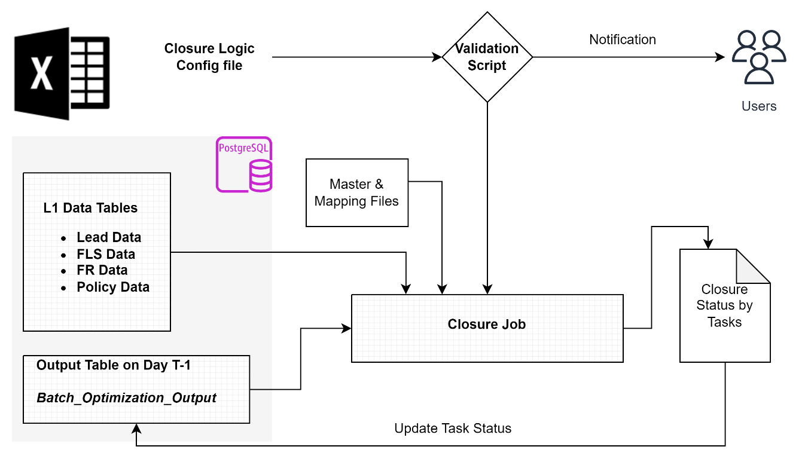

Fig. Closure Module
- Task closure module checks the open tasks assigned to an FLS/FC and then validates with the closure logic whether the task has been completed or not.
- If completed within the due_date, it updates the Task_Status as “Closed” or else keeps it “Open”
- If the due date has passed, it marks the status as “Missed”
- For checking the task closure logic, Task Closure Config column needs to be validated and used
- Task Closure Config needs to be maintained by Admin users
Task_id | Task_Desc | Iteration Level | Closure_True_Query
1 | Establish first contact (call) and setup a meeting time with your existing lead of X by <date> |  | (((lead.first_meeting_scheduled_date>optimization_output.proc_date) &( (lead.db_last_upd>proc_date) & (lead.db_last_upd<optimization_output.due_date))) OR  ((lead.first_meeting_held_date>optimization_output.proc_date) & (lead.first_meeting_held_date_upd<optimization_output.due_date)))
2 | Complete first meeting for lead X by <date> |  | ((lead.latest_meeting_held_date>optimization_output.proc_date) & (lead.latest_meeting_held_date_upd<optimization_output.due_date) ))
3 | Sell atleast 1 policy with EPI greater than XX by <date> | Policy | (((policy_data.issuance_date>optimization_output.proc_Date) & (policy_data.issuance_date<optimization_output.due_date)) AND ((policy.first_reciept_date>optimization_output.proc_Date) & (policy.first_reciept_date<due_date)) AND ((policy_data.epi>optimization_output.xx_value)))
4 | Sell at least 1 policy by <date> | Policy | (((policy_data.issuance_date>optimization_output.proc_Date) & (policy_data.issuance_date<optimization_output.due_date)) AND ((policy.first_reciept_date>optimization_output.proc_Date) & (policy.first_reciept_date<due_date)))

Fig. Sample Trigger Closure Config (Detailed version in Appendix)

Column1: Task_id: Task Number
Column2 : Task_Desc: Task Description
Column 3: Iteration Level: For some tasks where no specific lead id, fr id or policy id is tagged with the task, development code needs to iterate over all the respective leads, FRs or Policies assigned to the individual FLS/FC and check the required condition. For same iteration level column provides Key on which the iteration needs to take place
Ex. Task 4 : Sell at least one Policy by <date>
For closure of above Task 4 assigned to an FLS/FC, the logic should first scan all the polices converted by the FLS/FC between the proc date and due date. If the count is greater than 1, close the task or else keep it Missed/Open as per the due date
List of Keys:
- Lead: for iteration over all leads tagged to FLS/FC
- Policy: for iteration over all policies tagged to FLS/FC
- FR: for iteration over all FR tagged to FLS/FC
Column 4: Closure_True_Query
- Closure_True_Query column will provide the query which the development code needs to utilize as is in their code, to check the TRUE/FALSE criteria of the closure condition.
- It will be the responsibility of Admin team to maintain correct Closure_True_Query. In case of any error, the process should notify the Admin team about Query error and fallback to previous working version of the configuration
- To establish correct closure query logic for 19 Tasks as finalized, will be the dev team responsibility under the scope of the project. Future changes and updates need to be owned by the Admin Team
EXPECTED JOB PROCESS
Step 1: Batch_Optimization_Output table/file of T-1 should be read and open tasks around the FLS/FC should be identified
Step 2: Run and validate the TRUE/FALSE Status of the Closure logic from Task_Closure_Config for each Open tasks tagged with the FLS/FC
STEP3 : Structure the intermediate closure output as below (or the development team can decide as per requirement)
Fig. Closure Module Output

STEP 4: Task closure status should be updated on the Batch_Optimization_Output File/Table generated a day before (T-1) and then should be used in further modules
Module | Task Closure Verification
Description | This use case outlines the process of task closure verification within the Task Closure Module. The module checks open tasks assigned to Field Level Supervisors (FLS/FC) and validates their completion based on defined closure logic. The status of the task is updated accordingly. Admin users are responsible for maintaining the Task Closure Config, which defines the closure logic.
Actor(s) | - FLS/FC (Field Level Supervisors/Financial Consultants)  - Admin Users  - Development Team (Dev Team) (changing SQL queries)
Trigger | Daily Scheduled Process after Data Ingestion Module run is completed
Pre-conditions | - Task Closure Config is maintained and finalized by Admin users.  - Open tasks are assigned to FLS/FC.  - The Task Closure Module is accessible and operational.
Main Scenario | Step 1: Task Status Verification  1.1. The Task Closure Module retrieves open tasks assigned to an FLS/FC.  1.2. For each task, the module verifies the status based on the defined closure logic.  Step 2: Closure Logic Evaluation  2.1. The module checks if the task has been completed within the due date.  2.2. If completed within the due date, the Task_Status is updated as "Closed."  2.3. If not completed within the due date, the Task_Status is marked as "Missed."  Step 3: Iteration Level Check  3.1. For tasks that require iteration over leads, policies, or FRs, the module identifies the appropriate iteration key.  3.2. The module iterates over the relevant leads, policies, or FRs, as specified in the Task Closure Config.  3.3. It evaluates the defined closure logic for the task based on the iteration results.  3.4. If the closure conditions are met, the Task_Status is updated to "Closed"  Step 4: Closure Logic Evaluation Query  4.1. The module retrieves the Closure_True_Query from the Task Closure Config for the specific task.  4.2. It utilizes the query in the code to check the TRUE/FALSE criteria of the closure condition. 4.3. The closure query logic is applied to verify task completion.  Step 5: Admin Responsibility  5.1. Admin users are responsible for maintaining correct Closure_True_Query in the Task Closure Config.  5.2. In case of any query error, the process notifies the Admin team.  5.3. If an error occurs, the system falls back to the previous working version of the configuration.
Alternative Flows | Step 2 - Task Not Completed: 2.2. If the task is not completed within the due date, and the logic criteria are not met, the Task_Status remains "Open."
Post-conditions | - The Task Closure Module has verified the status of open tasks assigned to FLS/FC.  - Task_Status is updated as "Closed," "Missed," or "Open" based on the closure logic.  - The module has checked tasks requiring iteration over leads, policies, or FRs as per the Task Closure Config.  - Admin users are informed of any query errors, and the system reverts to a working configuration.
Exceptions | - If any critical errors or issues prevent the configuration process, the Admin user works with the BA to address and resolve them

Task Eligibility & Trigger Module
- Objective of TNT module is to check whether the FLS/FC is eligible for a Task or not
- Task eligibility is based on trigger conditions.
- Each task can have one or more triggers where each one is either optional or mandatory
- An FLS/FC is eligible for the task if the required Trigger conditions for the Task eligibility are True
Refer: Task & Trigger_Mapping config file and data lineage in appendix
Business requirement is to have a templatized config file to adjust all the required mappings so that the objective of configuration changes and future scalability does not require any code development effort.
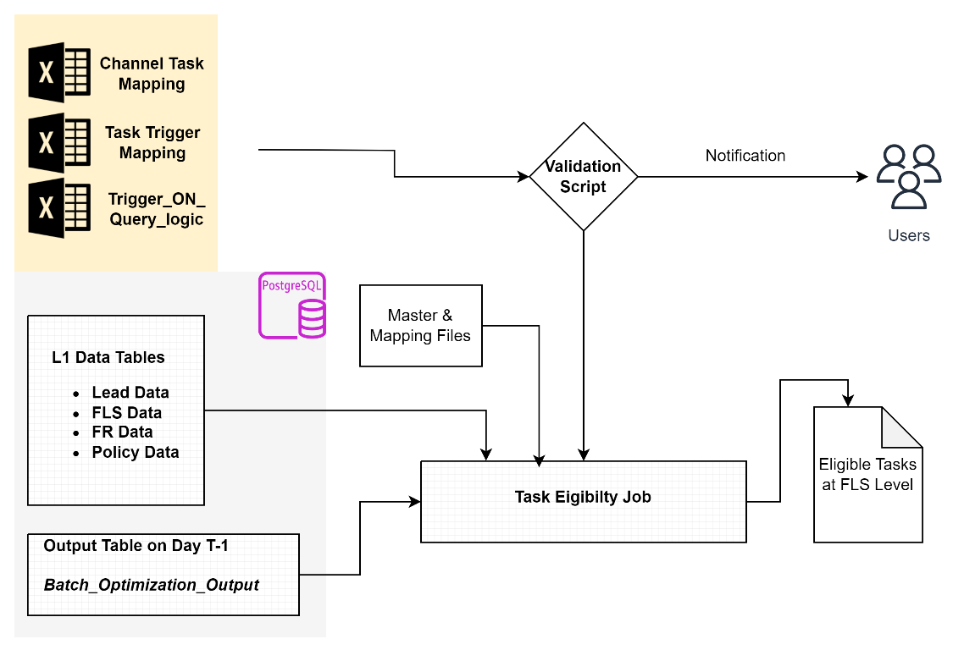
Fig Task & Trigger Module
As per the mutual discussion it was decided to maintain three config files as below
  - Channel-Task-Mapping
  - Task-Trigger-Mapping
  - Trigger-ON-Query-Logic

  - Channel-Task-Mapping

- Channel-Task-Mapping File/Table should have the mapping of Tasks required for a Channel-Subchannel-DemoSeg-ValueSeg combination
- Channel-SubChannel_ID Mapping will come Channel-SubChannel Mapping Master file
- DemoSeg-ValueSeg-ID Mapping will come from DemoSeg-ValueSeg Mapping Master file
- Lists of Tasks will be provided as input in the file. This will indicate which all Tasks are active for the respective microsegment and channel-subchannel combination
- Admin can update the configurations, add & delete tasks or microsegments and still the system should run without any development requirements
Channel | Channel_Subchannel_ID | channel_subchannel_Name | DemoSeg_ValueSeg_ID | DemoSeg_ValueSeg_Name | Task
Direct | 10 | Direct_DSC | 12 | Urban Lateral Hires_Policy Champs | [1,2,3,4,5,6,7,8,9,10,11,12,14,16,17,18,20,28,13a,13b,13c,13d,13e,13f,13g,13h,13i,13j,15a,15b,15c,15d,15e,15f,15g,15h,'15i','15j']
Direct | 10 | Direct_DSC | 12 | Small Town Established_Potentials | [1,2,3,4,5,6,7,8,9,10,11,12,14,16,17,18,20,28,13a,13b,13c,13d,13e,13f,13g,13h,13i,13j]
Agency | 10 | Direct_DSC | 11 | Small Town Established_Middle Joes | [4,5,6,7,8,11,12,14,17,28,13a,13b,13c,13d,13e,13f,13g,13h,13i,13j,15a,15b,15c,15d,15e,15f,15g,15h,15i,15j]
Direct | 13 | Direct_BCSS | 12 | Urban Lateral Hires_Policy Champs | [1,2,3,4,5,6,7,8,9,10,11,12,14,16,17,18,20,28,13a,13b,13c,13d,13e,13f,13g,13h,13i,13j,15a,15b,15c,15d,15e,15f,15g,15h,15i,15j]
Direct | 11 | Direct_Defence | 12 | Urban Lateral Hires_Policy Champs | [1,2,3,4,5,6,7,8,9,10,11,12,14,16,17,18,20,13a,13b,13c,13d,13e,13f,13g,13h,13i,13j,15a,15b,15c,15d,15e,15f,15g,15h,15i,15j]
Direct | 12 | Direct_Loyalty | 12 | Urban Lateral Hires_Policy Champs | [1,2,3,4,5,6,7,8,9,10,11,12,14,16,17,18,20,28,13a,13b,13c,13d,13e,13f,13g,13h,13i,13j,15a,15b,15c,15d,15e,15f,15g,15h,15i,15j]
Banca | 16 | Banca_HDFC | 15 | Seasoned Small Towners_Policy Champs | [2,4,5,6,7,8,9,10,11,12,14,16,18,20,13a,13b,13c,13d,13e,13f,13g,13h,13i,13j,15a,15b,15c,15d,15e,15f,15g,15h,15i,15j]
Banca | 17 | Banca_Otherbanks | 15 | Seasoned Small Towners_Policy Champs | [2,4,5,6,7,8,9,10,11,12,14,16,18,19,20,21,13a,13b,13c,13d,13e,13f,13g,13h,13i,13j,15a,15b,15c,15d,15e,15f,15g,15h,15i,15j]
Fig. Sample Channel-Task Config (Detailed version in Appendix)

Refer Config_Template_051023

Module | Use Case : Configure Channel and Trigger Mapping
Description | This use case outlines the process of configuring the Task around t specific Channel-Subchannel-DemoSeg- Value-Seg in the TNT module. Admin users are responsible for setting up the mapping between tasks and their associated trigger conditions, specifying whether triggers are optional or mandatory.
Actor(s) | - Admin Users  - Development Team (Dev Team) (changing SQL queries)
Main Scenario | Step 1: Define Channel-Task Mapping  1.1. Admin users access the Channel & Task Mapping configuration.  1.2. They specify which tasks are associated with each microsegment  Step 2: Save Configuration  2.1. Admin users save the Channel- Task Mapping configuration.
Post-conditions | - Task and Trigger Mapping configuration is saved and ready for use.  - Tasks are associated with the required trigger conditions, with their optional or mandatory status defined
Exceptions | - If any critical errors or issues prevent the configuration process, the Admin user works with the BA to address and resolve them

  - Task-Trigger-Mapping
- This file/table should maintain the configuration around what combination of Trigger conditions needs to be true for making a task eligible for any FLS/FC
- The representation is in key value pair format
- Value can have either “O” (stands for optional) or “M” (stands for mandatory)
Ex. Task 1 requires either T1 and T2 trigger conditions to be true. {T1:O, T2:O} and Task 5 requires Trigger 8 to be mandatorily True and Trigger 9 to be Optionally True
- Task_Stage gives information around the Task impact on the life cycle of a customer journey. Ex. Task 1 impacts in lead conversion by pushing the agent to set up a meet with prospect within due date
- In future Admin can change the combination of Trigger requirement for a task
- Two tasks can have same Trigger conditions
Task_id | Task_Desc | Task_Stage | Trigger
1 | Establish first contact (call) and setup a meeting time with your existing lead of X by <date> | Lead Conversion - Pre Login | {1:O,2:O}
2 | Complete first meeting for lead X by <date> | Lead Conversion - Pre Login | {3:O,4:O}
3 | Sell atleast 1 policy with EPI greater than XX by <date> | Lead Conversion - Pre Login | {35:M}
4 | Sell at least 1 policy by <date> | Lead Conversion - Post Login | {36:M}
5 | Complete verification of the existing open application id XX by <date> | Lead Conversion - Post Login | {8:M,9:O}
6 | Resolve medical FR of application id- XX by <date> | Lead Conversion - Post Login | {37:M,38:O, 39:O}
7 | Resolve non medical FR of application id- XX by <date> | Lead Conversion - Post Login | {40:M,41:O,42:O}
8 | Resolve single non medical FR of application id- XX by <date> | Lead Conversion - Post Login | {43:M,44:O,45:O}
9 | Sell at least 1 combo by <date> | Combo Task | {9:O,46:O}
Fig. Sample Task Trigger Mapping Config (Detailed version in Appendix)
Module | Use Case 2: Configure Task and Trigger Mapping
Description | This use case outlines the process of configuring the Task and Trigger Mapping in the TNT module. Admin users are responsible for setting up the mapping between tasks and their associated trigger conditions, specifying whether triggers are optional or mandatory.
Actor(s) | - Admin Users  - Development Team (Dev Team) (changing SQL queries)
Main Scenario | Step 1: Define Task-Trigger Mapping  1.1. Admin users access the Task and Trigger Mapping configuration.  1.2. They specify which triggers are associated with each task.  1.3. For each trigger, they indicate whether it is optional (O) or mandatory (M).  Step 2: Save Configuration  2.1. Admin users save the Task-Trigger Mapping configuration.
Post-conditions | - Task and Trigger Mapping configuration is saved and ready for use.  - Tasks are associated with the required trigger conditions, with their optional or mandatory status defined
Exceptions | - If any critical errors or issues prevent the configuration process, the Admin user works with the BA to address and resolve them

  - Trigger-ON-Query-Logic

- This file/table should maintain the configuration around which query should be run to check whether the Trigger condition is True or False
- The config should have list of all unique Triggers needed for any Tasks
- Trigg_Desc column will explain the Trigger Definition
- Any Trigger condition should be checked at an individual FLS/FC level
- For some Triggers, additional iteration will be required ex. In Trigger2 for any given FLS/FC, we need to check for all the leads tagged with him/her and then identify for which all leads the Trigger condition is True. If from 10 leads, Trigger condition is True for 3, the TNT output should first flag the Trigger as ON and next also store for which all Lead_ids the Trigger was ON
- Similarly, iteration can be at different dimensions defined by following keywords
  - LEAD – for iterating over all the leads tagged to the FLS/FC
  - FR – for iterating over all the FRs tagged to the FLS/FC
  - POLICY – for iterating over all the policies tagged to the FLS/FC
  - Optimization_Output– for iterating over all the tasks of Optimization_Output tagged to the FLS/FC
- Trigger_ON_Query_Logic column will provide the query which the development code needs to utilize as is in their code, to check the TRUE/FALSE criteria of the trigger.
- Trigger_ON_Query_Logic might use the FLS and segment level thresholds calculated and stored by the monthly Threshold pipeline
- It will be the responsibility of Admin team to maintain correct Trigger_ON_Query_Logic. In case of any error, the process should notify the Admin team about Query error and fallback to previous working version of the configuration
- To establish correct query logics for 37 Triggers as finalized, will be the dev team responsibility under the scope of the project. Future changes and updates needs to be owned by the Admin Team
Trigger_id | Trigg_Desc | Iteration_Level | Trigger_ON_Query_Logic
1 | If Last N month's avg TAT between lead generation and set up of meeting has been greater than segment benchmark X |  | Threshold2> Threshold1
2 | If X days have elapsed after lead generation, and yet first meeting has not been setup (applicable for all leads with status "New" without a future meeting date) | Lead | (lead_generation_date -  first_meeting_scheduled_date) > Threshold1
3 | If X days have elapsed after lead generation, and yet first meeting has not been conducted (applicable for all leads with status "New" with a future meeting date) | Lead | { ((lead_generation_date - latest_meeting_scheduled_date)> Threshold1) OR ((lead_generation_date -  first_meeting_scheduled_date)>Thresold1)} where lead.lead_status="new"
4 | If Last N month's avg TAT between lead generation and first meeting has been greater than segment benchmark X |  | t4_threshold2> t4_Threshold1
Fig. Sample Trigger_ON_Logic Config (Detailed version in Appendix)
EXPECTED JOB PROCESS
Step 1: Read and validate config files
Step 2: For each FLS/FC, run and validate the TRUE/FALSE status of the Trigger condition from Trigger-ON-Query-Logic.
STEP 3: Structure the intermediate TNT output as below (or the development team can decide as per requirement)
Sno | fls_id | task_no | id_type | id | due_date | xx_type | xx_value | proc_date | triggers_qualified | proxy_due_date | task_output
0 | 1279619 | 1 | lead_id | 1-200901402682 |  |  |  | 18-01-2023 | {1 : nan, 2: 0} |  | 0
1 | 1189216 | 1 | lead_id | 1-200892836185 |  |  |  | 18-01-2023 | {1 : nan, 2: 0} |  | 0
2 | 1140378 | 1 | lead_id | 1-200821854917 | 18-01-2023 |  |  | 18-01-2023 | {1 : nan, 2: 1} | 18-01-2023 | 1
3 | 1140378 | 1 | lead_id | 1-200834757093 | 18-01-2023 |  |  | 18-01-2023 | {1 : nan, 2: 1} | 18-01-2023 | 1
4 | 1140378 | 1 | lead_id | 1-200834828153 |  |  |  | 18-01-2023 | {1 : nan, 2: 0} |  | 0
5 | 1140378 | 1 | lead_id | 1-200834888320 | 18-01-2023 |  |  | 18-01-2023 | {1 : nan, 2: 1} | 18-01-2023 | 1
6 | 1140378 | 1 | lead_id | 1-200841717462 | 18-01-2023 |  |  | 18-01-2023 | {1 : nan, 2: 1} | 18-01-2023 | 1
7 | 1140378 | 1 | lead_id | 1-200847922192 |  |  |  | 18-01-2023 | {1 : nan, 2: 0} |  | 0
8 | 1140378 | 1 | lead_id | 1-200867788529 | 18-01-2023 |  |  | 18-01-2023 | {1 : nan, 2: 1} | 18-01-2023 | 1
Fls_id= FLS_ID
Task_no= TASK_No
Id_Type: For some of the task definition we need to include the lead_id ,fr_id, application_id,policy_number as inputs.
Ex.
Task 1 | Establish first contact (call) and setup a meeting time with your existing lead of X by <date> | Lead Conversion - Pre Login | {T1:O,T2:O}

Above we need to state in the verbose for which Lead_id the FLS should set up the meeting as “Establish first contact (call) and setup a meeting time with your existing lead of 1-200826679213 by < 18-01-2023>”
ID Type can be lead_id ,fr_id, application_id,policy_number
Id: Value of the ID_type
Due_date: This will be fetched from Allocation Parameters config and calculated based on current date + due days + buffer days(if available) benchmarks
XX_type: XX Type is additional level ID variable if required to pass in the verbose of the Task
XX type can be the lead_id, fr_id, application_id, policy_number, product_name or others as inputs.
Ex. For Task 5 it will be “Complete verification of the existing open application id 1338093788195 of lead id 1-193001563425 XX by <date>
XX_value: Value of XX_type
Proc_date: Date of generation of the task
Proxy_due_date= Due Date + Buffer days as per the allocation parameters config
Triggers Qualified: keeps the status of which all triggers qualified for the task in Key Value format
Task Eligibility flag: This is the column which specifies whether the FLS/FC is eligible for the task or not

Module | Use Case 3: Task Eligibility Verification
Description | This use case outlines the process of verifying task eligibility for FLS/FCs in the TNT module. The module checks whether FLS/FCs are eligible for specific tasks based on trigger conditions.
Actor(s) | - FLS/FC (Financial Service Representatives/Financial Consultants)  - Admin Users
Main Scenario | Step 1: Read and Validate Config Files  1.1. The TNT module reads and validates the Task and Trigger Mapping and Trigger Query Logic configurations.  Step 2: Verify Task Eligibility for FLS/FC  2.1. For each FLS/FC, the module runs and validates the TRUE/FALSE status of trigger conditions from Trigger Query Logic.  2.2. It checks whether the required trigger conditions for task eligibility are true.  Step 3: Structure the Intermediate TNT Output  3.1. The module structures the intermediate TNT output for each task, including the FLS_ID, TASK_No, and ID_Type.  3.2. It specifies the verbose information, including which ID_Type (e.g., lead_id, fr_id, application_id, policy_number) is required for the task.  3.3. The module calculates the Due_date based on allocation parameters and due days benchmarks.  3.4. Additional variables like XX_type and XX_value are added if needed.  Step 4: Identify Qualified Triggers  4.1. The module identifies which triggers qualified for the task in Key-Value format.
Pre-conditions | - The TNT module is operational.  - Task and Trigger Mapping and Trigger Query Logic configurations are defined.  - FLS/FCs are assigned tasks.  - Allocation Parameters and due days benchmarks are set
Post-conditions | - Task eligibility is verified for FLS/FCs based on trigger conditions.  - Intermediate TNT output is structured, including verbose task information.  - Qualified triggers are identified for each task.

Task Optimization & Assignment Module
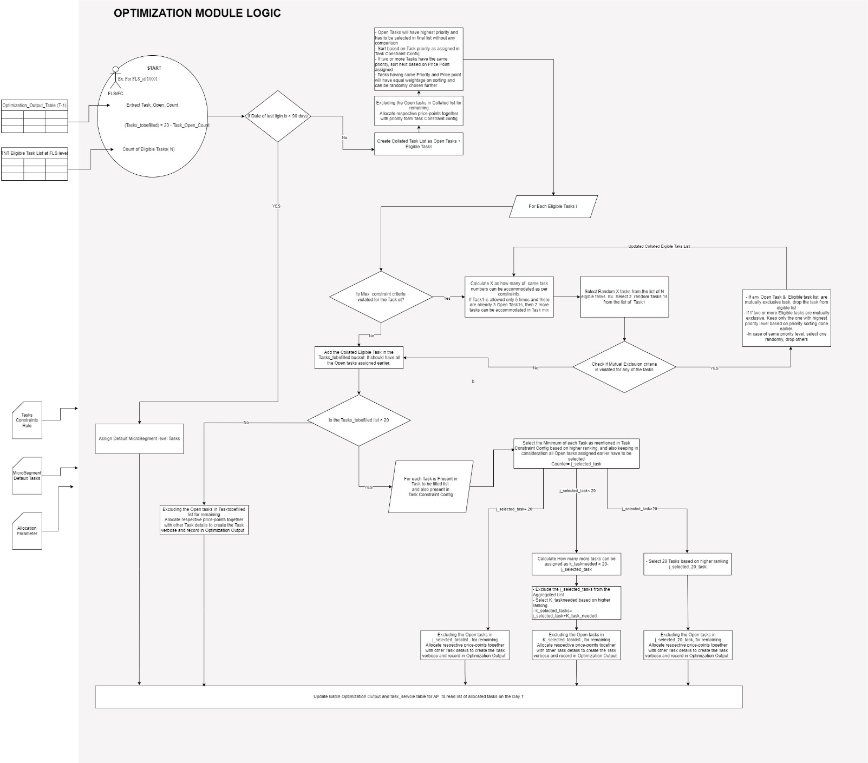
Fig. Optimization Logic Flow
- Each FLS/FC can be assigned maximum of 20 Tasks
- Each Tasks might have constraint on maximum number of times it can be assigned
- Each Tasks might have constraint on minimum number of times it should be assigned
- Some Tasks can be mutually exclusive for example if Task 13a is assigned 13b cannot be assigned
Steps:
1. Receive and validate Task Constraints Rule
2. Receive and validate Task Allocation Parameters
3. Receive and validate Microsegment Default Tasks
4. Run Optimization and Allocation Scripted logic
Step 1. Constraints on specific tasks will be provided through Task Constraints Rule config file, structure of which is shown and explained below

Task No | Constraint Description | Category Task Associated with | Min Task Count/FLS | Max Task Count/FLS | Mutual Exclusion Criteria | Task Priority
1 | Task 1 should be allocated max == 5 | Meeting Task |  | 5
2 | Task 2 should be allocated max == 5 | Meeting Task |  | 5
3 | Task 3 should be allocated min 1 | Lead_Conversion - Pre Login | 1 |  |  | Medium
4 | Task 4 should be allocated min 1 | Lead_Conversion - Post Login | 1 |  |  | High
5 | Task 5 should be allocated min 1 | Lead_Conversion - Post Login | 1 |  |  | High
6 | Task 6 should be allocated min 1 | Lead_Conversion - Post Login | 1 |  |  | High
7 | Task 7 should be allocated min 1 | Lead_Conversion - Post Login | 1 |  |  | High
8 | Task 8 should be allocated min 1 | Lead_Conversion - Post Login | 1 |  |  | High
10 | Task 10 should be allocated min: 1, max: 1 | Overall Sales | 1 | 1
11 | Task 11 should be allocated max == 5 | Renewal Task |  | 5
12 | Task 12 should be allocated max == 5 | Renewal Task |  | 5 |  | Medium
14 | Task 14 Should be allocated min 1 | Birthday Task | 1 |  |  | Low
17 | Task 17 not mandatory / >=0 | Lead Generation
18 | Task 18 should be allocated min:1, max: 1 | Lead Conversion - Pre Login | 1 | 1
20 | Task 20 should be allocated min 1 | Login To Issunace | 1 |  |  | High
28 | Task 28 Should be allocated min 1 | Renewal Task | 1 |  |  | High
13a | 13a | Selling Task | 1 |  | ["13b"] | High
13b | 13b | Selling Task | 1 |  | ["13a"] | High

Detailed sample file is in Appendix . Column level explanation given below.
Task No | Task No
Constraint Description | Description of Constraint
Category Task Associated with | Type of task based on lifecycle. Ex. Selling Task Meeting Task etc.
Min Task Count/FLS | Minimum number of times a task should be there in Task mix
Max Task Count/FLS | Maximum number of times a task should be there in Task mix
Mutual Exclusion Criteria | Tasks which cannot be together in Task Mix. Ex. Task 13a and Task 13b cannot be assigned together
Task Priority | It is the priority level set up by the business for Tasks. Tasks with Priority 1 are the most priority Tasks while tasks with Priority 5 are minimum Priority Task

Step 2: Allocation Parameter Config
Task_id | Channel | Subchannel | DemoSeg | ValueSeg | Segment_id | Due_Days | Buffer Days | XX_Value | XX_Type | PricePoint(Reward)
1 | Direct | BCSS | 1 | 1 | 11 | 2 | 1 |  |  | 200
2 | Direct | Loyalty | 1 | 1 | 11 | 2 | 1 |  |  | 300
3 | Direct | BCSS | 1 | 2 | 12 | 2 | 1 |  |  | 250
4 | Direct | Loyalty | 1 | 2 | 12 | 2 | 1 |  |  | 350
13d | Direct | BCSS | 2 | 3 | 23 | 5 | 1 | category | non_par_c2p | 500

Task_no= TASK_No
Due_days: Due days for the task in the microsegment
Buffer Days: If any additional buffer days to be added for calculating due day for closure
XX_type: XX Type is additional level ID variable if required to pass in the verbose of the Task
XX type can be the lead_id, fr_id, application_id, policy_number, category or others as inputs.
Ex. For Task 5 it will be “Complete verification of the existing open application id 1338093788195 of lead id 1-193001563425 XX by <date>
XX_value: Value of XX_type
Price Point: This the reward in Rupees at microsegment level which will be given to FLS/FC if they close the task. It is assumed that these price points will be provided by the HDFC Life team and the process to calculate or optimize price point is not in the scope of the project. Hence Budget constraints have not been considered.
Step3: Below is the layout for the Microsegment Level Default Tasks where default tasks are set of tasks which don’t require any computation for assignment. Ex. Task can be “Register new 10 leads”, here the same tasks can be given to any FLS in the valid microsegment irrespective of FLS behavior

Channel | Subchannel | DemoSeg | ValueSeg | Segment_id | Default Tasks
Direct | BCSS | 1 | 1 | 11 | [D1,D2,D3]
Direct | Loyalty | 1 | 1 | 11 | [D1,D2]
Direct | BCSS | 1 | 2 | 12 | [D1,D2,D3,D4,D5,D6,D7,D9,D10]
Direct | Loyalty | 1 | 2 | 12 | [D2]
Direct | BCSS | 2 | 3 | 23 | [D1]

Step 4: Logic for Task Assignment
- For any FLS/FC and a task, if it has reached top allowed count, TNT module processing for this FLS should not be done for this task
- If agent login has not logged in 3 months, do not process TNT module for this FLS. Instead, assign default micro segment level default tasks from MicroSegment Default Task file
- The maximum number of tasks that can be assigned is 20. There can be scenarios where there can be less than 20 tasks.
- Open Tasks are those tasks which have been assigned earlier by the iEarnv2 process and still are active in progress stage.
- Closed Tasks are those tasks which were earlier assigned to FLS/FC and has been completed by the FLS/FC.
- Missed Tasks are those tasks which were earlier assigned to FLS/FC but has not been completed by the FLS/FC within proxy due date
- Create Collated Task List as Open Tasks + Eligible Tasks
- Excluding the Open tasks in Collated Task list for remaining, allocate respective price-points using Task allocation parameters together with priority form Task Constraint config
- Create Rankings based on below logic
  - Open Tasks will have highest priority and has to be selected in final list without any comparison
  - Sort based on Task priority as assigned in Task Constraint Config
  - If two or more Tasks have the same Task priority, sort next based on Price Point assign. Lower Price Point gets higher ranking
  - Tasks having same Priority and Price point will have equal weightage on sorting and can be randomly chosen further in processes
- For Each Eligible Tasks i,
    - Check if max constraint criteria is violated or not.
      - If for a task Max assignment criterion is being violated
        - Calculate X as how many of same task numbers can be accommodated as per constraints. Ex. If Task1 is allowed only 5 times and there are already 3 Open Task1s, then 2 more tasks can be accommodated in Task mix
        - Select Random X tasks from the list of N elgible tasks. Ex. Select 2 random Tasks 1s from the list of Task1
        - Check if Mutual Exclusion criteria is violated for any of the tasks
          - If the mutual Exclusion criterion is violated, follow below rules
            - If any Open Task & Eligible task list are mutually exclusive task, drop the task from eligible list
            - If two or more Eligible tasks are mutually exclusive, keep only the one with highest priority level based on priority sorting done earlier.
            - In case of same priority level, select one randomly, drop others
            - Go back to Step (a ) above and repeat
          - If the mutual Exclusion criterion is not violated, follow below rules
            - Go to Step (2) below
      - Add the Collated Elgible Task in the Tasks_tobefilled bucket. It should have all the Open tasks assigned earlier.
      - If number of tasks in Tasks_tobefilled bucket is less than or equal to 20
        - Excluding the Open tasks in Tasktobefilled list, for remaining allocate respective price-points together with other Task details to create the Task verbose and record in Optimization Output
      - If number of tasks in Tasks_tobefilled bucket is greater than 20
        - For each Task is Present in Task _tobefilled list and also present in Task Constraint Config follow below steps
          - Select Minimum of each Task as mentioned in Task Constraint Config based on highest ranking, and also keeping in consideration all Open tasks assigned earlier have to be selected. For understanding say Counter= j_selected_task
          - If j_selected_task=20
            - Excluding the Open tasks in j_selected_tasklist , for remaining Allocate respective price-points together with other Task details to create the Task verbose and record in Optimization Output
          - If j_selected_task<20
            - Calculate How many more tasks can be assigned as k_taskneeded = 20-j_selected_task
            - Exclude the j_selected_tasks from the Aggregated List
            - Select K_task needed selecting the top ranked ones
            - Output will k_selected_tasks= j_selected_task+K_task_needed
            - Excluding the Open tasks in K_selected_tasklist , for remaining allocate respective price-points together with other Task details to create the Task verbose and record in Optimization Output
          - If j_selected_task>20
            - Select 20 Tasks based on ranking keeping in consideration to select all the Open tasks as j_selected_20_task
            - Excluding the Open tasks in j_selected_20_task, for remaining allocate respective price-points together with other Task details to create the Task verbose and record in Optimization Output

Admin Console UI
ß--TBD--à
Wireframe Link
https://www.figma.com/proto/LA3RhzsqtgvMlMiD4kMz1p/HDFC_IVE?page-id=0%3A1&type=design&node-id=1-2&viewport=397%2C373%2C0.53&t=3yE3NxNAomiFeABA-1&scaling=scale-down&mode=design
Product Category and product selection for training tasks
Product Category and product selection for selling tasks
Product Category and product selection for contest tasks
From range of task variety, task creation to be enabled
Product master mapping from backend

Performance Tracking Qlik Dashboards
ß--TBD--à

Serving API connectivity with iEarn App Frontend
- There is an existing API request-response structure where iEarn frontend request data from iEarn backend task_service table (separate for agency and direct channel)
- There is user_analytics table to capture user login and also many other API urls and dynamodb table mapped on multiple lambda function
- There are separate lambdas for Direct and Agency Channel. Detail view is in API Lambda relationship.
- Objective is to align the iEarnv2 FLS/FC task allocation outcomes in the same format as the existing one so that there is no change or development is required from Frontend team
- Current API integration needs to be migrated to Adcat account
- The expected application login per day is below ~1000 and concurrency to be maintained at 50 requests per seconds
- Backend technology and API serving process can be decided by the development team
- Do we need to migrate all lambdas and dynamodb table and validate each API domain url?..in planning phase --// Discovery in Progress

Expected Production Stage End Stage
- Three system environments to be maintained – Dev- UAT – PROD
- Each should have its own appropriate billing and identification tags
- CI/CD will be implemented to maintain Code version, review, and deployment
- Job Process Monitoring is essential, and any failure alerts should be mailed to respective stakeholders as soon as possible
- Quality status and data flow Logs with intermediate files to review should be available for developer/support or analyst teams
- Security setup and access polices need to be implemented as per HDFC Life instructions
- Stakeholders with Admin access can change configurations directly on config files or through UI
- Processes, guidelines, and any relevant operational knowhow should be documented
- Data Serving Through API is validated and tested and iEarn frontend functionalities are working fine
- Custom Tasks are daily allocated to FLS/FCs based on the microsegment they belong to, with maximum of 20 tasks to be allocated
- FLS/FCs get updates on closure of tasks and rewards associated with it

Development Priorities
During the requirement discovery, there were specific priorities from the HDFC Life leadership team. Below are the list of priorities in descending order:
- Team should start working on Prototype assuming some L1(consumption layer) sample data as per the data model requirement and build end to end working processes except data ingestion and ETL step. Also assume flat S3 files instead of AWS RDS (Postgres)
- Once source mapping, data sanity validation and accesses are resolved. ETL pipeline for each of the data requirement at L1 can start building up
- AWS RDS Schema and data process should be established in parallel to ETL pipeline
- Integrate the validated and tested prototype processes with ETL processes
- Migrate API requirements and validate the new solution
- Develop Admin Console UI
- Develop Dashboards

System Requirements
- Development objective to process only required data and operations to maintain least processing time
- No Data Redundancy should be taken as guideline to lower storage cost
- Minimal AWS services usage and cheap runtime cost should be the focus
- System should be scalable with more numbers of Channels, Tasks, Triggers without manual changes on code
- System should support 10000 FLS/FCs logins per day with concurrency of 100 requests per second
- All infra elements should be trackable with respect to billing

Integration Requirements
- All the modules should be synchronized and streamlined to generate output within the scheduled time
- Connectivity with the iEarn Application to send required responses for API requests
- Admin Console Frontend connectivity with the configuration tables/files to make required changes in config elements
- Qlik connectivity with reporting data to create dashboards

Non-Functional Requirements

Scalability should be validated and tested to handle future needs

Performance
- Expected Response Time:
  - API requests
  - ETL processes
  - UI interactions

- Throughput: “ “ maximum number of requests or data records that the system should handle per unit of time, supporting the expected load.

Reliability
- Targeted uptime percentage (e.g., 99.9%)
- Redundancy: Implement redundancy and failover mechanisms to ensure service availability in case of hardware or software failures.
- Backup Frequency: Specify how often data backups should occur and the retention period for backups.
- Disaster Recovery: Develop and test a disaster recovery plan to recover the system in the event of catastrophic failures.
- Fault Isolation: Ensure that failures in one component or module do not lead to system-wide outages.

Security
- Access Control: Define role-based access control (RBAC) and permissions to restrict access to sensitive data and functionality.
- Audit Trails: Maintain audit logs to track user activities and system changes for security and compliance purposes.

Data Integrity
- Data validation and cleansing should ensure a data accuracy rate of at least <99.5%>. Datalake will be taken as the source of truth for all validation
- Duplicate data should be minimized, with an allowed duplicate rate of less than <0.5%>.
- Data lineage should be tracked to ensure traceability from source to target.

Monitoring and Logging
- Suggest strategy for logs retention to meet technical requirements within minimal cost.
- Monitoring tools should be able to detect and alert for critical issues within <5> minutes to respective stakeholders
- Log analytics should be performed to identify trends and potential issues proactively.

Compliance
- Access Controls: Enforce access controls and permissions to ensure that only authorized personnel can access sensitive data or perform regulated actions.

Cost Efficiency
- Resource Monitoring: Continuously monitor resource utilization and costs to identify opportunities for optimization.
- Auto-scaling: Implement auto-scaling policies to dynamically adjust resource allocation based on workload, reducing unnecessary costs during low traffic periods.
- Cost Allocation Tags: Apply cost allocation tags to AWS resources for better cost tracking and allocation to specific project phases.
- Resource Rightsizing: Regularly review and right size AWS resources to match actual usage and avoid over-provisioning.

Documentation
1. Documentation should cover design, code, testing, and operations procedures, and be easily accessible to relevant stakeholders.
2. A knowledge base should be established to share best practices, lessons learned, and troubleshooting guides.

Reusability
1. Code should be reusable across different components and data sources.
2. Common functions and libraries should be centralized and shared across the pipeline to reduce duplication and simplify maintenance.
3. Best practices for code reuse and modular design should be documented and enforced across the development team.
4. The error handling and data quality rules should be applied via a similar design pattern to developments for consistency.

Exception Handling Error Reporting
Exception/ Error ID | Solution Strategy
Code Breakdown | Best practises around try-exception, comments for easily debugging, process logs to be maintained and failure notifications integrated
Access Issues | Access validation based on IAM role.  Access Mapping with stakeholders to be maintained
Data | Data Quality Check processes integrated in modules, data flow logs will be maintained, and Job failures will be notified
Config rules | Config Validation scripts
System / Service Outage

Stakeholder Mapping
Expected accesses at module level is given in below table
Module | FLS/FC | Admin/Cong Team | Business users | Developer
1. ETL Pipeline from Data Lake/EDW to L1 |  |  |  | Yes
2. Monthly Threshold Pipeline |  |  |  | Yes
3. Task Eligibility & Trigger Module |  |  |  | Yes
4. Task Optimization & Assignment Module |  |  |  | Yes
5. Task Closure Module |  |  |  | Yes
6. Config Files |  | Yes |  | Yes
7. Admin Console UI |  | Yes | Yes | Yes
8. Performance Tracking Qlik Dashboards |  |  | Yes | Yes (BI developer only)
9. Serving API | Yes |  |  | Yes
10. DevOps & Monitoring Requirements |  |  | Yes | Yes (DevOps team only)

Assumptions & Pre-requisites
- All the data points for banca channel related to tasks/ triggers / rule engine to be available from day 1
- For banca channel task & Trigger will be of similar type as Direct and Agency i.e., no new variables will be introduced as part of addition for banca channel.
- All the Trigger rules & Task logic to be available from day 1 (+access to codebase)
- All the AWS services or any ancillary services currently supporting iEarn needs to there from day 1 implementation
- Source data will be available in .csv/parquet format.
- Data is consistent and of sufficiently good quality.
- Production parallel run will not undertake Change Requests. The CRs will be budgeted for separately.
- Business will adhere to defined UAT timelines and raise defects in a timely fashion. The team will fix the defects raised within that timeline only.
- The infra to be provided by HDFC Life needs to be available from Day 1 of implementation.
- At least one point of contact from HDFC Life is identified for Exponentia team to get in touch with for any queries or information. We would route all our queries to the business stakeholders through this SPOC.
- HDFC Life would inform Exponentia about its Information security policies and requirements thereof in order to execute the project in a timely manner

Exclusions
- Business Requirement for Bonanza tasks are not included in this proposal
- API testing activities with iEarn APP frontend functionalities are not included.
- Domain name and Route 53 mapping will be done by HDFC Life team.
- InfoSec Checks will be implemented by Exponentia but the software and guidelines has to be provided by HDFC Life team

APPENDIX
  - Channel Demo Seg and Value Seg Mapping
Direct |  |  |  | Banca |  |  | Agency
Demographic | Value |  |  | Demographic | Value |  | Demographic | Value
Urban Lateral Hires | Policy Champs |  |  | Seasoned Small Towners | Policy Champs |  | Urban Lateral Hires | Policy champs
Small town Established | Potentials |  |  | Small Town Sophomores | Profitable Moderates |  | Small Town Established | Middle Joes
Urban Sophomores | Middle Joes |  |  | Urban Lateral Hires | Savings Advocates |  | Vintage Loyalists | Health Policy Stars
Urban Established | Profitable Moderates |  |  | Steady Small-Town Growers | Potentials |  | Hinterland Hires | Savings Advocates
Middle aged Freshers | Low Pulse |  |  | Urban Established | Low Pulse |  | Experienced Town Recruits | Low Performers
 |  |  |  | Urban Newbies

  - Batch Optimization Output
  - User Analytics Table
  - Task service Table
  - Master Files
  - Data mapping
  - Config Mapping

